**Glen Forrest Physiotherapy**

# 2/5 Hardey Road, Glen Forrest, 6071

**Phone** : ( 08) 9298 9648

# Fax:( 08) 9298 9538

**Email:** [mail@glenforrestphysio.com.au](mailto:mail@glenforrestphysio.com.au)

**PATIENT INFORMATION**

PATIENT REFERRAL

Date

Name: Date of Birth:

Address:

Phone:

Email:

**REFERRING DOCTOR INFORMATION**

Doctor Name:

Phone:

Address:

Email:

Please provide a description of the service and or support that the patient requires.

**TREATMENT REQUESTED**

**CLINICAL NOTES**

Please provide a description of the service and or support that the patient requires.

**SERVICE REQUIRED**

Private

Motor Vehicle Injury Pelvic Health

EPC Plan

Hydrotherapy Private Vet Affairs Workplace Injury

Other

Please email this form back to [mail@glenforrestphysio.com.au](mailto:mail@glenforrestphysio.com.au) with any necessary referral documents and images. Thank You!

Glen Forrest Physiotherapy 2/5 Hardey Road,

Glen Forrest, 6071

Phone: (08) 9298 9648

Fax: (08) 9298 9538

[mail@glenforrestphysio.com.au](mailto:mail@glenforrestphysio.com.au)

Bassendean Physiotherapy 1/89 Old Perth Rd,

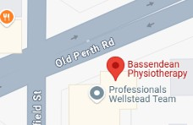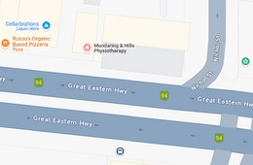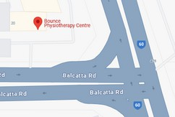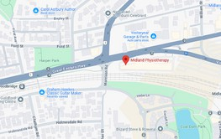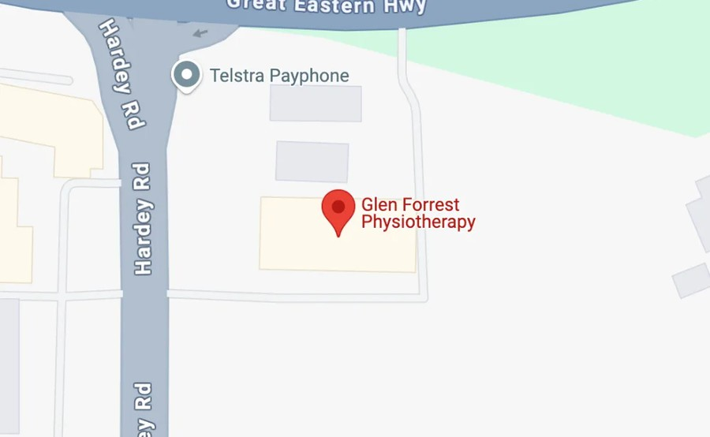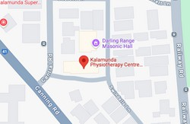

Bassendean 6054

(08) 9279 7411

[mail@bassendeanphysio.com.au](mailto:mail@bassendeanphysio.com.au)

Bounce Physiotherapy Suite 19/257 Balcatta Rd,

Balcatta 6021

(08) 9344 7476

[reception@bouncephysiowa.com.au](mailto:reception@bouncephysiowa.com.au)

Midland Physiotherapy

3/401 Great Eastern Highway,

Midland, 6056

(08) 9274 1482

[mail@midlandphysio.com.au](mailto:mail@midlandphysio.com.au)

Kalamuda Physiotherapy 45 Central Rd

Kalamunda, WA 6076

(08) 9279 7411

[mail@kalamundaphysio.com.au](mailto:mail@kalamundaphysio.com.au)

Mundaring & Hills Physiotherapy 1/7145 Great Eastern Hwy,

Mundaring 6073

(08) 9295 2381

[mail@mundaringhillsphysio.com.au](mailto:mail@mundaringhillsphysio.com.au)